* **Lab Task 6:**

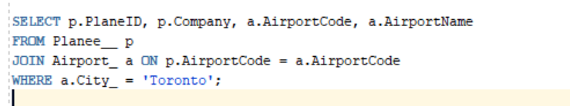The HR department needs a report of employees in Toronto. Write a SQL statement to display the last name, job, department number, and the department name for all employees who work in Toronto.

OUTPUT:

